FAQs answered

Who we are
- St John’s Church Playgroup has run for 40 years.
- We are a Christian setting overseen by St John’s Church Welling.
What we offer
- Friendly, caring and stimulating sessions for 2,3 and 4 years olds with highly qualified staff.

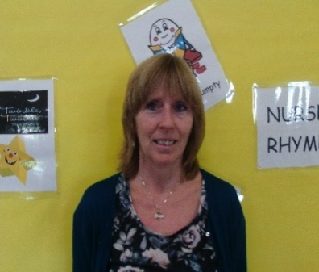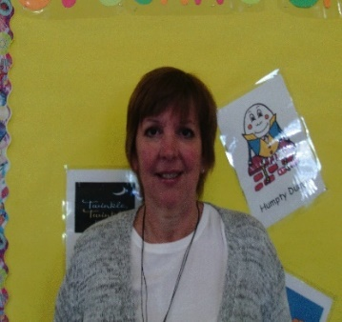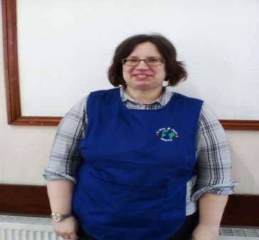
Julie Stedman -Manager Carole Ellery- Deputy Lucie Brasova
QTS Level 6 SENCO Level 5 Playgroup Assistant Level 6
Child protection Fundraising coordinator petty cash
Behaviour management Events manager
Staff appraisal reviews
Admissions
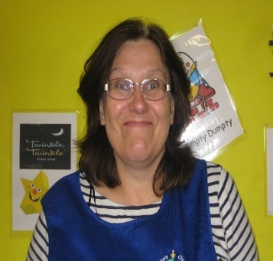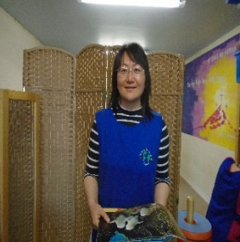
Laura Greenhead L3 Julia Flack L6 ZhiyanXie L3 Lindsey Rosier L3
Playgroup Assistant PlaygroupAssistant Playgroup assistant Playgroup assistant
Caterpillar planner enabling environmentS 2 year planner Book coordinator

Session times
- Open term times
- Monday – Friday from 9-12 AND Monday 12 -3
- Your child could stay all day on Monday if you wish.
OFSTED
- We are OFSTED registered and rated ‘Good’ at our last inspection.
Waiting list
- We have a waiting list which you can put your child on if they are not yet 2 years old.

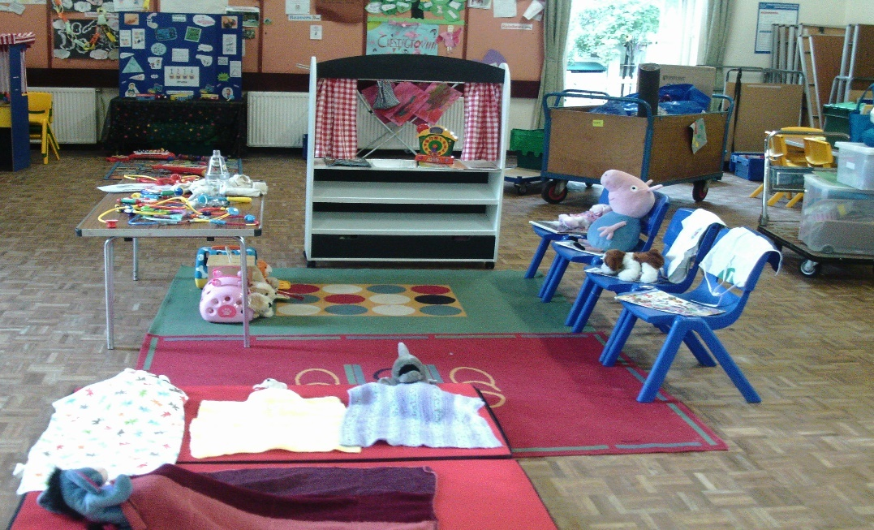

Funding/fees
- All 3 and 4 year olds are entitled to 15 hours funding
- Some 2 year olds receive funding if you are eligible.
- Some 3/4 year olds are eligible for 30 hours funding. We can offer you 18 hours and you can make up the rest with a child minder or at another setting.
- Fees are £13.50 per session for those not funded, payable half termly in advance.
- We ask for a £25 deposit which will be refunded when you make your first payment.
- If it causes difficulty to pay this much in a lump sum then speak to Julie we will make an alternative arrangement to suit your needs.
- Fees are still payable if your child is absent from playgroup for any reason.

Numbers and ratios

- We are registered to have up to 32 children per session
- The ratios are one adult to four 2 year olds and one adult to eight 3 / 4 year olds
- We have 7 permanent members of staff
- We have some volunteers and cover staff
- Our staff are highly qualified. The manager is a qualified teacher. There 2 other teachers, a Level 5 and 3 Level 3s.

Key Workers

- Each child is assigned to a Key Worker.
- The KW is responsible for daily assessments and observations as well as writing liaison reports and records of transfer for schools.
- Each child will have a Learning Journey when they leave playgroup which will have been put together by your KW.
- Please get to know your child’s KW and take time to discuss his/her development.

Daily routine

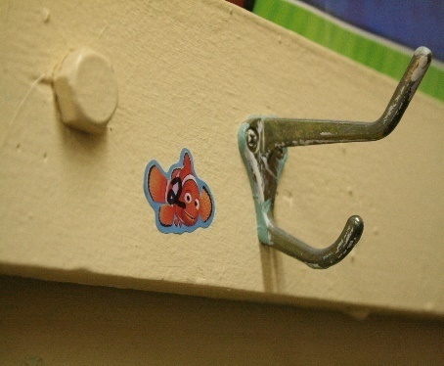
- Help your child to put their coat and bag on their peg
- Put their name card on the registration board
- Put fruit on the table
- Take them into the hall to settle to an activity
- You can leave when you feel happy that they have settled.
- At 9.30 we will bring the children to the carpet for our prayer and song, and then split into our differentiated groups.
- Caterpillar group: for the older children to prepare them for school and includes, number work, shapes, writing skills and phonics.
- ECAT (Every Child a Talker) group: for children who need extra support with their speaking and language development.
- Meerkats group: for the younger children to learn about the topic of the week in a smaller group.
- 10.00 – 11.15: children have a free flow session with opportunities to explore and interact. There will be fruit and drinks available and adult led activities both inside and in the garden. Activities will be set up to cover all of the areas of Learning and Development in the Early Years Foundation Stage.
- We have a large space inside and a lovely garden area where we provide climbing equipment, sand, water and other PE items.
- 11.15: we encourage the children to tidy up!
- 11.30: physical activities which include, parachute games, keep fit, circle games etc and story time.
- 12.00: prepare to go home with a prayer and a song.
- Parents/carers will collect their child from the Frank Moore Room at the end of the hall.

- SPORTY TOTS
- Every Wednesday a Sporty Tots coach comes in and teaches different skills eg football, basketball, tennis, cricket etc. This is an extra activity which you pay the coach for if you would like your child to take part.

What you need to do
- As explained above, help your child to settle.
- Provide a piece of fruit each day which all the children will share.
- Bring a bag with a spare change of clothes/nappies and put this on your child’s peg.
- PLEASE DO NOTleave any food or drinks in your child’s bag in case other children investigate and have allergies.

If you are late
- We will not let your child go with anyone we don’t know.
- Please ring us on 07780725684 (manager) or 07719341984 (general enquiries) as soon as possible to let us know if you are going to be late or who you have arranged to collect your child. This will avoid confusion and upset.
- If a child is not collected we agree to wait 30 minutes to allow for traffic or other circumstances that can’t be avoided.
- The child will be looked after by a member of staff to avoid upset.
- We will attempt to contact parents using the numbers you have given us.
- If we are unable to contact a parent or responsible adult, we will contact Bexley Social Services for advice.
- Please provide a password on the registration form to be used if you send someone different to pick up your child, but please let us know you are doing this. Please do not divulge your password to other people for your child’s safety.

Volunteering/staying
- We encourage parents to volunteer in our setting.
- You would need to have a DBS check done with us and complete the volunteer pack.
- You could come in as a visitor as a ‘one off’ if you have something in particular you would like to share with the children.
- You are welcome to stay of you feel it will help your child to settle.
- You are welcome to come and visit if you would like to discuss your child with us.
Nappies
- We accept that some children have not yet acquired the skills needed for using the toilet independently and as stated in our Equal Opportunities Policy, we will not discriminate against any child. We therefore include those children into playgroup with regard for their personal privacy. You will be asked to sign your consent for us to change your child’s nappy and it is your responsibility to provide nappies and wipes etc. A parent may choose to sign that they wish to be contacted and come to change their child themselves.

Ethos

- The overall ethos of the group is Christian and we run under the direction of the church, however, we embrace all children and families from different cultures and faith backgrounds. Your child will never be forced to pray but we ask that they respect those who do. We extend that respect to families from a different faith and welcome you to share your beliefs and traditions with us.

Equal opportunities
- Our policy is that NO child will ever be rejected on the grounds of gender, class, means, family status, disability, skin colour, ethnic origin, religion or culture.
- We welcome all children to our playgroup and make them feel loved and cared for in an environment of love, friendship, faith and happiness.

Special Educational Needs
- We do whatever we can to ensure safe appropriate inclusion of any children that have SEN. We have a SENCO (SEN coordinator) and we ensure that our group operates with regard to the SEN code of practice as defined by the Government.
- If you have any concerns about your child’s needs please speak to Julie (manager) or Carole (SENCO) who will either offer advice or put you in contact with professionals who can.

Behaviour management
- At St John’s Church Playgroup we believe that children and adults flourish best in an ordered environment where they know what is expected of them.
- Children should be free to develop their learning through play without fear of being hurt or hindered by anyone else.
- We actively discourage aggressive behaviour such as hitting, kicking, pinching, biting, name calling or throwing toys.
- We will NEVER use physical punishment or threaten the use of it.
- If a child misbehaves, they will be removed from the situation and an adult will explain why the behaviour is unacceptable.
- If aggressive or anti-social behaviour persists, the parents will be consulted so that we can work together to help the child overcome this pattern of behaviour.
- The manager, Julie Stedman is our named Discipline and Behaviour Management Officer.
Complaints procedure

- If you are not happy about something at Playgroup please talk to Julie or Carole.
- Complaints in the first instance will be dealt with the Manager (Julie Stedman) who will try to find a prompt and satisfactory conclusion for all involved.
- Should a parent have a complaint they feel unable to discuss with the Playgroup leaders or that has been unresolved through discussion, they should contact the Church Office and ask to speak to the Vicar or a member of the Playgroup Council Tel: 0203031107.
- Serious unresolved concerns should be referred to OFSTED helpline 03001234666.
Child protection
- We take the safety of the children in our care very seriously and have several policies in place to make it our top priority.
- It is hoped that through these safety policies and procedures your child will be safe during their time at Playgroup.
- The manager (Julie Stedman) is our named Child Protection Officer.
- In line with Bexley Borough’s procedures regarding child protection issues, should Playgroup staff feel there is cause for concern that a child may be suffering abuse, their concerns will be shared with the Church PCR and/or the local Safeguarding Children Board without delay.

Accident procedures

- Equipment and toys are checked daily to minimise accidents.
- Risk assessments of the building are carried out daily.
- However, with children accidents are inevitable.
- All accidents are recorded on an accident sheet, however minor. Parents/carers are required to sign as proof that we have informed them.
- If a serious accident occurs, first aid will be administered and you will be notified as soon as possible after seeking medical assistance (ambulance).
- The Playgroup is covered through a special policy through the Church’s insurance.
- The policy covers accidents to children, staff, students on placement and also public liability.
- All of our staff have completed Paediatric First Aid training and are all DBS checked. The latter includes our volunteers and staff that do sickness cover.

For more information, please ask a member of staff or contact us on:

07780725684 (manager)

07719341984 (general enquiries)

stjohns.playgroup@btinternet.com

www.stjohnschurchplaygroupwelling.com

Before your child’s first day

- COMPLETE EMERGENCY CONTACT FORMS.
- TELL US ABOUT SPECIAL REQUIREMENTS EG FOOD ALLERGIES, RELIGIOUS REQUIREMENTS.
- FILL IN ANY ADDITIONAL FORMS REQUIRED.
- PAY £25 DEPOSIT IF YOU ARE FEE PAYING.

